

Hot Mess and Face In
A Candoco double bill at Bristol Old Vic

Visual Story

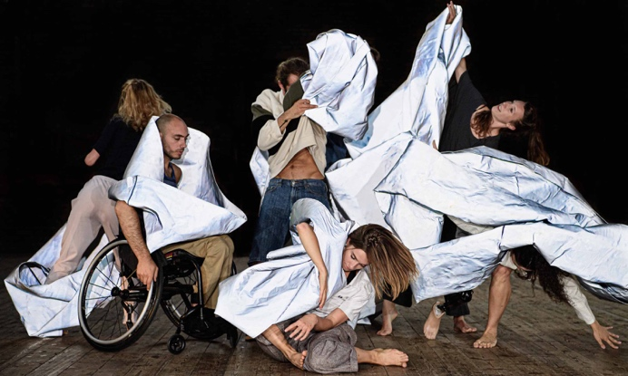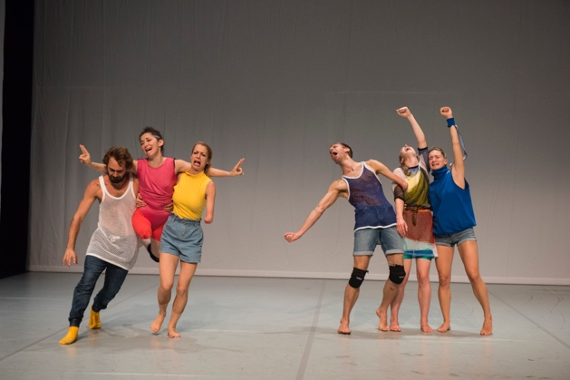

Hot Mess Photo: Stephen Wright Photography
Face In Photo: Hugo Glendinning

This visual resource is for audience members visiting Bristol Old Vic for Candoco Dance Company’s double bill between 25 – 26 February 2020. It is intended to help you prepare for a new experience and help you become familiar with the performance.

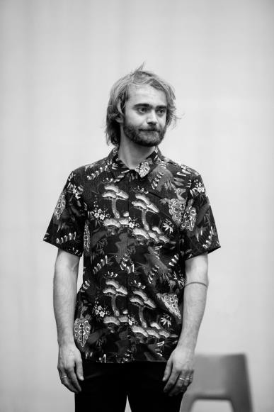
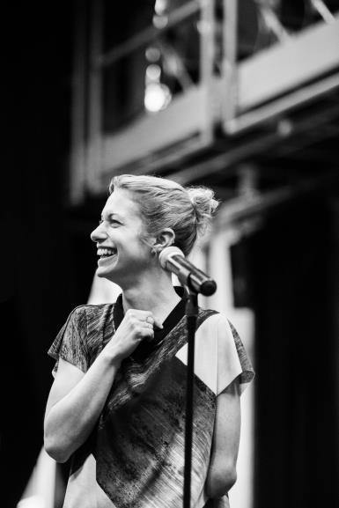
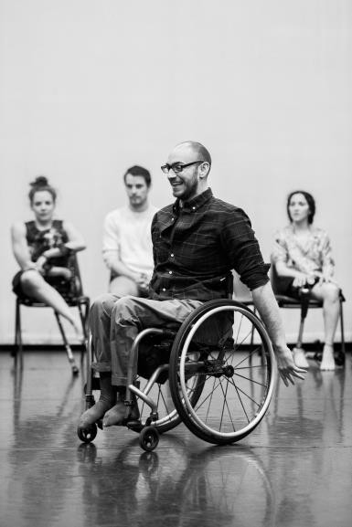
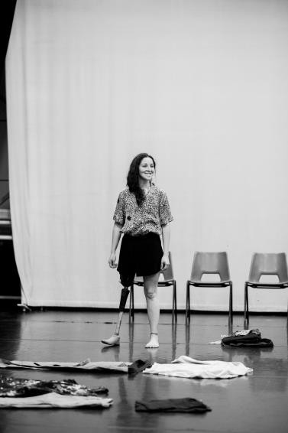
THE DANCERS
Toke Broni Strandby
Olivia Edginton
Megan Armishaw
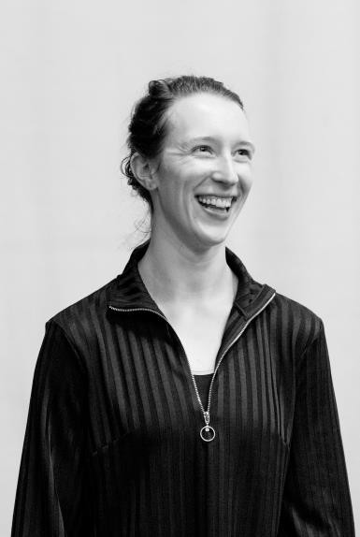
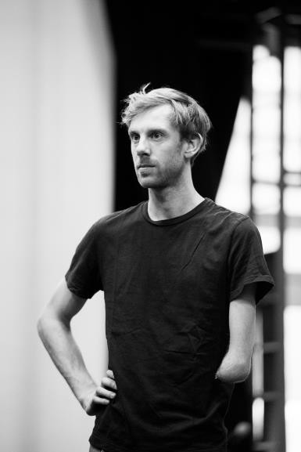
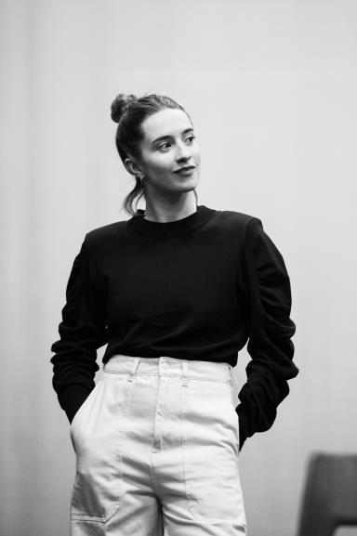
Mickaella Dantas
Nicolas Vendange  Joel Brown  Laura Patay |  | Joel Brown

ADDRESS

Bristol Old Vic, King Street, Bristol, BS1 4ED.

0117 987 7877

GETTING THERE

Bristol Old Vic is located on King Street, a 5-minute walk (0.2 miles) from the City Centre Harbourside.

There are bike racks on both King Street and Prince Street.

Bristol Old Vic is a 15-minute walk (0.8 miles) from Bristol Temple Meads railway station, or there are regular buses and taxis from outside the station. There is also a ferry which runs from the railway station into the City Centre. Bristol Bus Station is a 15-minute walk (0.7 miles) away. From Bristol Airport, it's 40 minutes by bus or 25 minutes by taxi to the City Centre. The Bristol Airport Guide has plenty of transport information.

We encourage visitors to travel by foot, bike or public transport in order to reduce transport emissions and improve Bristol's air quality.

There are good car parking facilities in the surrounding area including the NCP on Queen Charlotte Street which is a 2-minute walk (0.1 miles) and Trenchard Street car park, a 10-minute walk across the city centre (0.4 miles). Meter parking is also available on King Street and Queen Square. There is one disabled space right outside the theatre. Blue Badge Holders park for free.

For more information on parking, including options for minibuses and large vehicles, visit Bristol City Council parking services here.

Please book taxis for drop-off (and pick-up) to Bristol Old Vic, King Street, BS1 4ED.

There is space for two coaches to set-down and pick-up in front of The Rackhay. The closest coach park is near the M Shed museum (access off of Cumberland Road) with a fee of £1.10 for up to 24 hours (do check this before setting off). Read about coach parking in Bristol on the Travel West website.

AT THE VENUE

General Access
Our main entrance is at street level of King Street and fully wheelchair accessible with automatic doors to facilitate comfortable access. Our Foyer, 1766 Bar & Kitchen and Box Office are all fully wheelchair accessible. Our Foyer lift enables customers full access to all public areas of our building. Please find the full list of spaces accessible via lift below.
There are parking spaces around the corner on King Street for Blue Badge holders. (Please note that King Street is cobbled.)

The Theatre
There are two allocated wheelchair spaces in the Theatre in the Dress Circle. Please book these in advance by phoning 0117 987 7877 – and let us know of any other access requirements you have, so we can ensure your visit is as enjoyable as possible.
The Dress Circle is accessed from the Foyer via lift and there are accessible toilet facilities and step-free access to seats on this level. There is also access to the seating and dining area on the Foyer dais, perfect for interval drinks.
Please note that only the Dress Circle in the Theatre has step-free access to seats. All other levels (Pit, Upper Circle and Gallery) have steps in their seating areas. See Seating Plans for more information including step counts.
If you need additional information on navigating the building please email access@bristololdvic.org.uk.

Toilet Facilities
- We have accessible toilet facilities on Levels -1, 0 and 1, accessible via the foyer lift.
- Our toilets on Level -1 are signposted as gender-non-binary welcome. This is to show that customers who do not identify with a binary gender are welcome to use whichever washroom bearing this symbol that they prefer. Those who prefer to use gendered toilets can do so in the washrooms that bear gendered symbols only (on Level 1).
- We want everyone to feel welcome and comfortable using the toilet facilities at Bristol Old Vic. This is why we have signposted the washrooms as simply and clearly as possible. Our policy is to allow all customers to use whichever facility they wish, whilst asking that everyone respect each other, and behave appropriately around other users.
- Staff will only intervene in washrooms use if they are made aware of inappropriate behaviour, which will not be tolerated.
Access Facilities
- You can now book Access tickets online: to secure the full range of Access discounts you are entitled to, including free companion tickets, simply register for online booking with Box Office.
- A sound enhancement system through use of a headset or individual loop is available for all performances.
- Guide, hearing or other working dogs are welcome. Please notify Box Office at time of booking.
- People with disabilities requiring an accompanying person can request a free companion ticket at the time of booking.
Lift Access
All publicly available areas of Bristol Old Vic are accessible via our Foyer lift which goes to all levels:
- Level 4: Coopers’ Loft
- Level 3: Theatre (Gallery), Noises Off, Rehearsal Rooms
- Level 2: Theatre (Upper Circle)
- Level 1: Coopers’ Hall, The Foyle Room, Coopers’ Bar, Accessible Toilet Facilities
- Level 0: Theatre (Dress Circle), Accessible Toilet Facilities
- Level G: Foyer, The Weston Studio (Balcony), Box Office, 1766 Bar & Kitchen, Main Entrance
- Level -1: Theatre (Pit), The Weston Studio (Floor), Kiosk & Cloakroom, Public Lockers, Accessible Toilet Facilities

Face In
By Yasmeen Godder

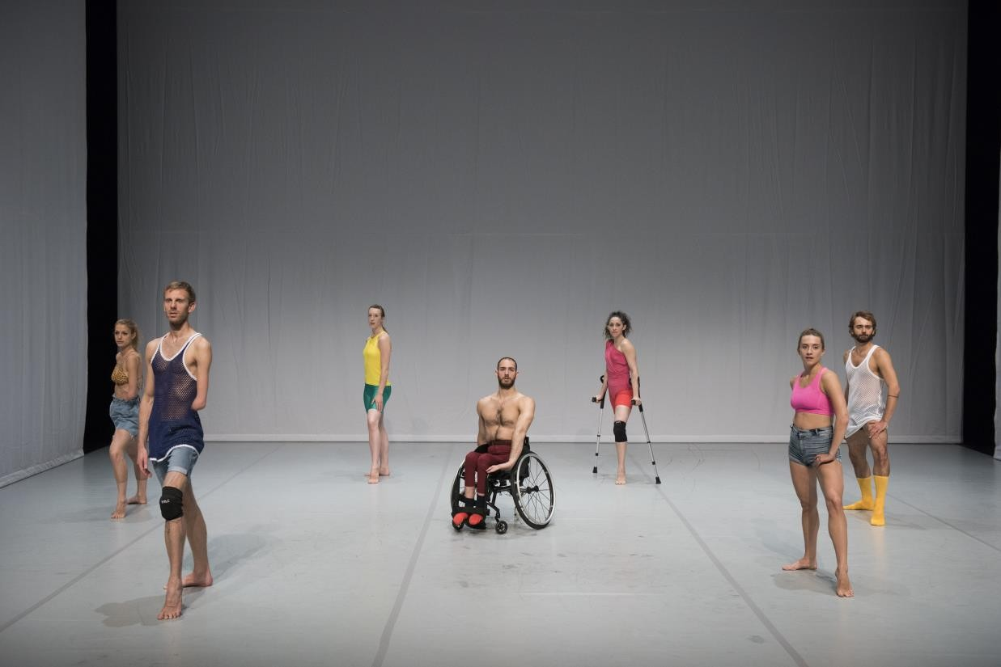

THE WORK

In Face In, Candoco invites you to dive in a fictional, imaginative world that might appear to you as troubling and intimate at the same time.

The dancers use both movement and noises in the piece such as screams and laughter. You might experience that their physical and vocal expressions are extreme. There are some sequences where the dancers are doing risky movements, but they are professionals and know how to stay safe.

This performance is high in energy and contains moments where the dancers may seem disturbing. This feeling of disturbance is not sustained throughout the whole piece. There are also funny and seductive moments.

The dancers are sometimes very close to each other and perform contact movement. Throughout the whole piece, they show exaggerated facial expressions.

You will experience moments of lighting effects and startling sound.

When you enter the auditorium, you will see the white curtains on either side of the stage already in place and a white/grey dancefloor. The piece begins with dancer Toke performing a solo on stage with no music at the start.

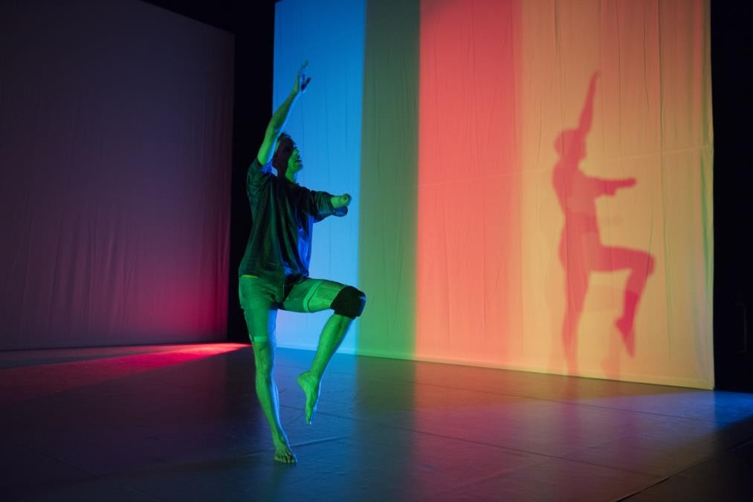

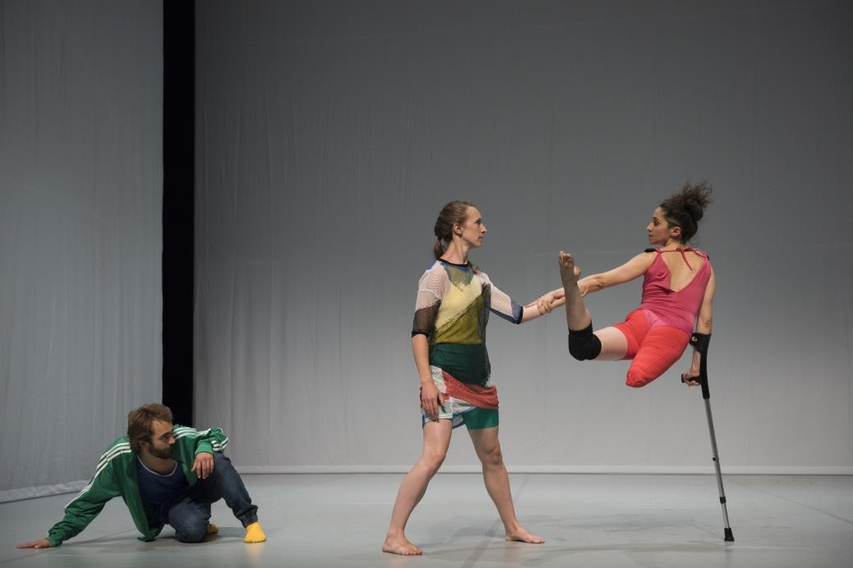
As Toke’s solo finishes, the lights have changed to plain white. Disturbing music starts and the rest of the dancers progressively enter the stage. The music increases in volume.

After a while, the lights dim to dark orange and the music changes to something happier. This sequence is funny, unexpected and sensual.

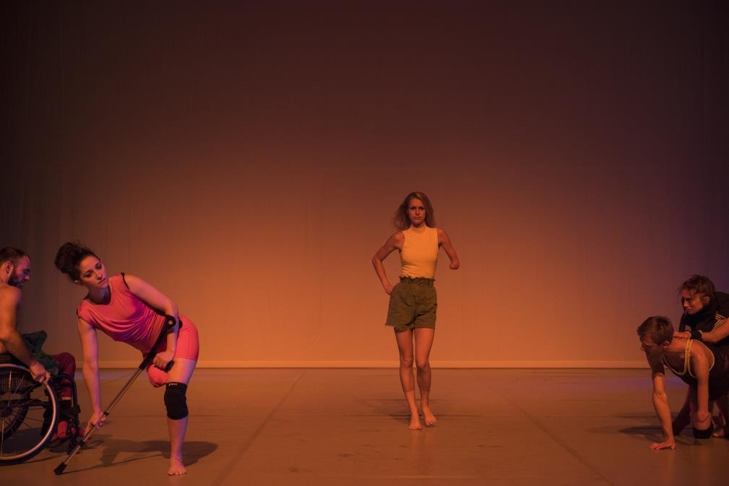

The lights return to white and the dancers explore their playfulness energetically in the scene. Some of the dancers scream in exaggerated crying.

Towards the end, the music stops. The dancers stay on stage for a while and then leave. Dancer Mickaella is the only one left on stage and performs a solo as the lights dim to the original, dark and colourful set. She makes a yodelling noise at the end.

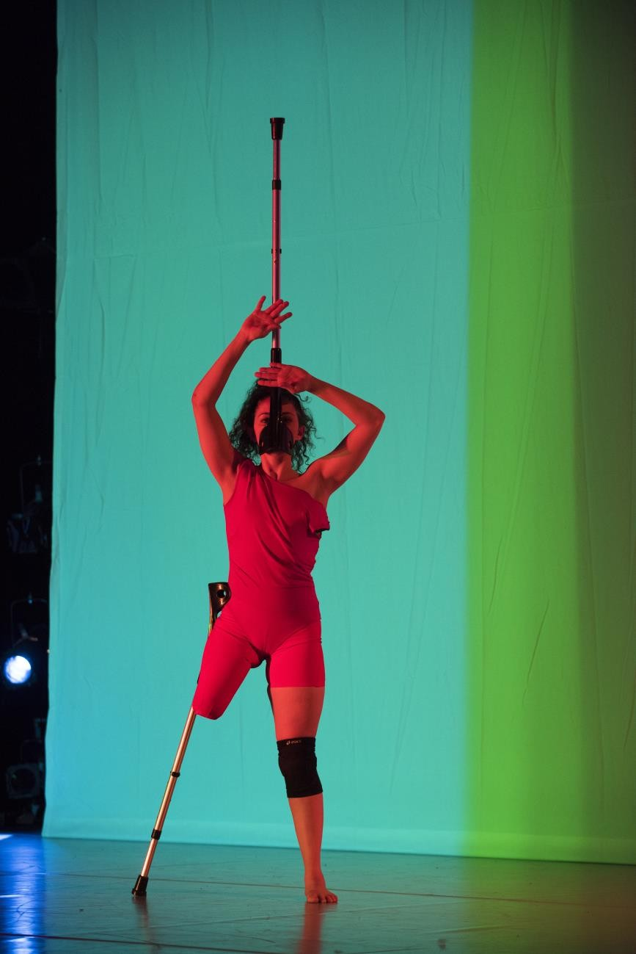

Sound
There is a mix of music used throughout Face In, from a range of different styles and using different instruments. During the first 15-minutes, the music is almost distressing and includes drone and gong-like sounds. The second half of the piece is set to an urban-indie score.

Sometimes, the music will increase in volume. You will also hear the dancers occasionally screaming or singing.

Lighting
The lighting will sometimes be very colourful, sometimes darker and sometimes lighter. There is no strobe. Please speak to a member of staff if you have any concerns.

Hot Mess
By Theo Clinkard

THE WORK

In this piece, the choreography is a series of physical practices rather than set movement. The dancers generate movement as they explore these practices, giving power to the group of dancers rather than the choreographer.

Theo Clinkard, the choreographer, is interested in creating a structure that gives space for the dancers’ individual voices and collective choices.

Sometimes you will see the dancers totally immersed in their own actions and at other times they will interact with each other as they seek to agree and organise themselves as a group without a pre-agreed plan. This is not an easy task so, at times, it can look absurd or humorous, it’s ok to laugh.

Hot Mess also plays with the idea of continuous potential rather than definition and completion. This is the choreographer’s artistic comment on our current political, social and environmental world; he perceives it to be in a state of instability, flux and chaos. This choreographic statement manifests in movement that is improvised and incomplete yet full of effort, will and the hope for group connection.

This list of words was accumulated during the process to act as an anchor for the dancers and to establish a shared philosophy.

This piece is rejecting: | This piece is celebrating:
the stable | the unformed
the fixed | the unknown
the polished | the potential
the repeatable | the collaborative
the product | the unplanned
the heroic | the process
the known | the unexpected
the formal | the failure
the ordered | the queer
the absolute | the precarious
the resilient | the disobedient
the known | the messy

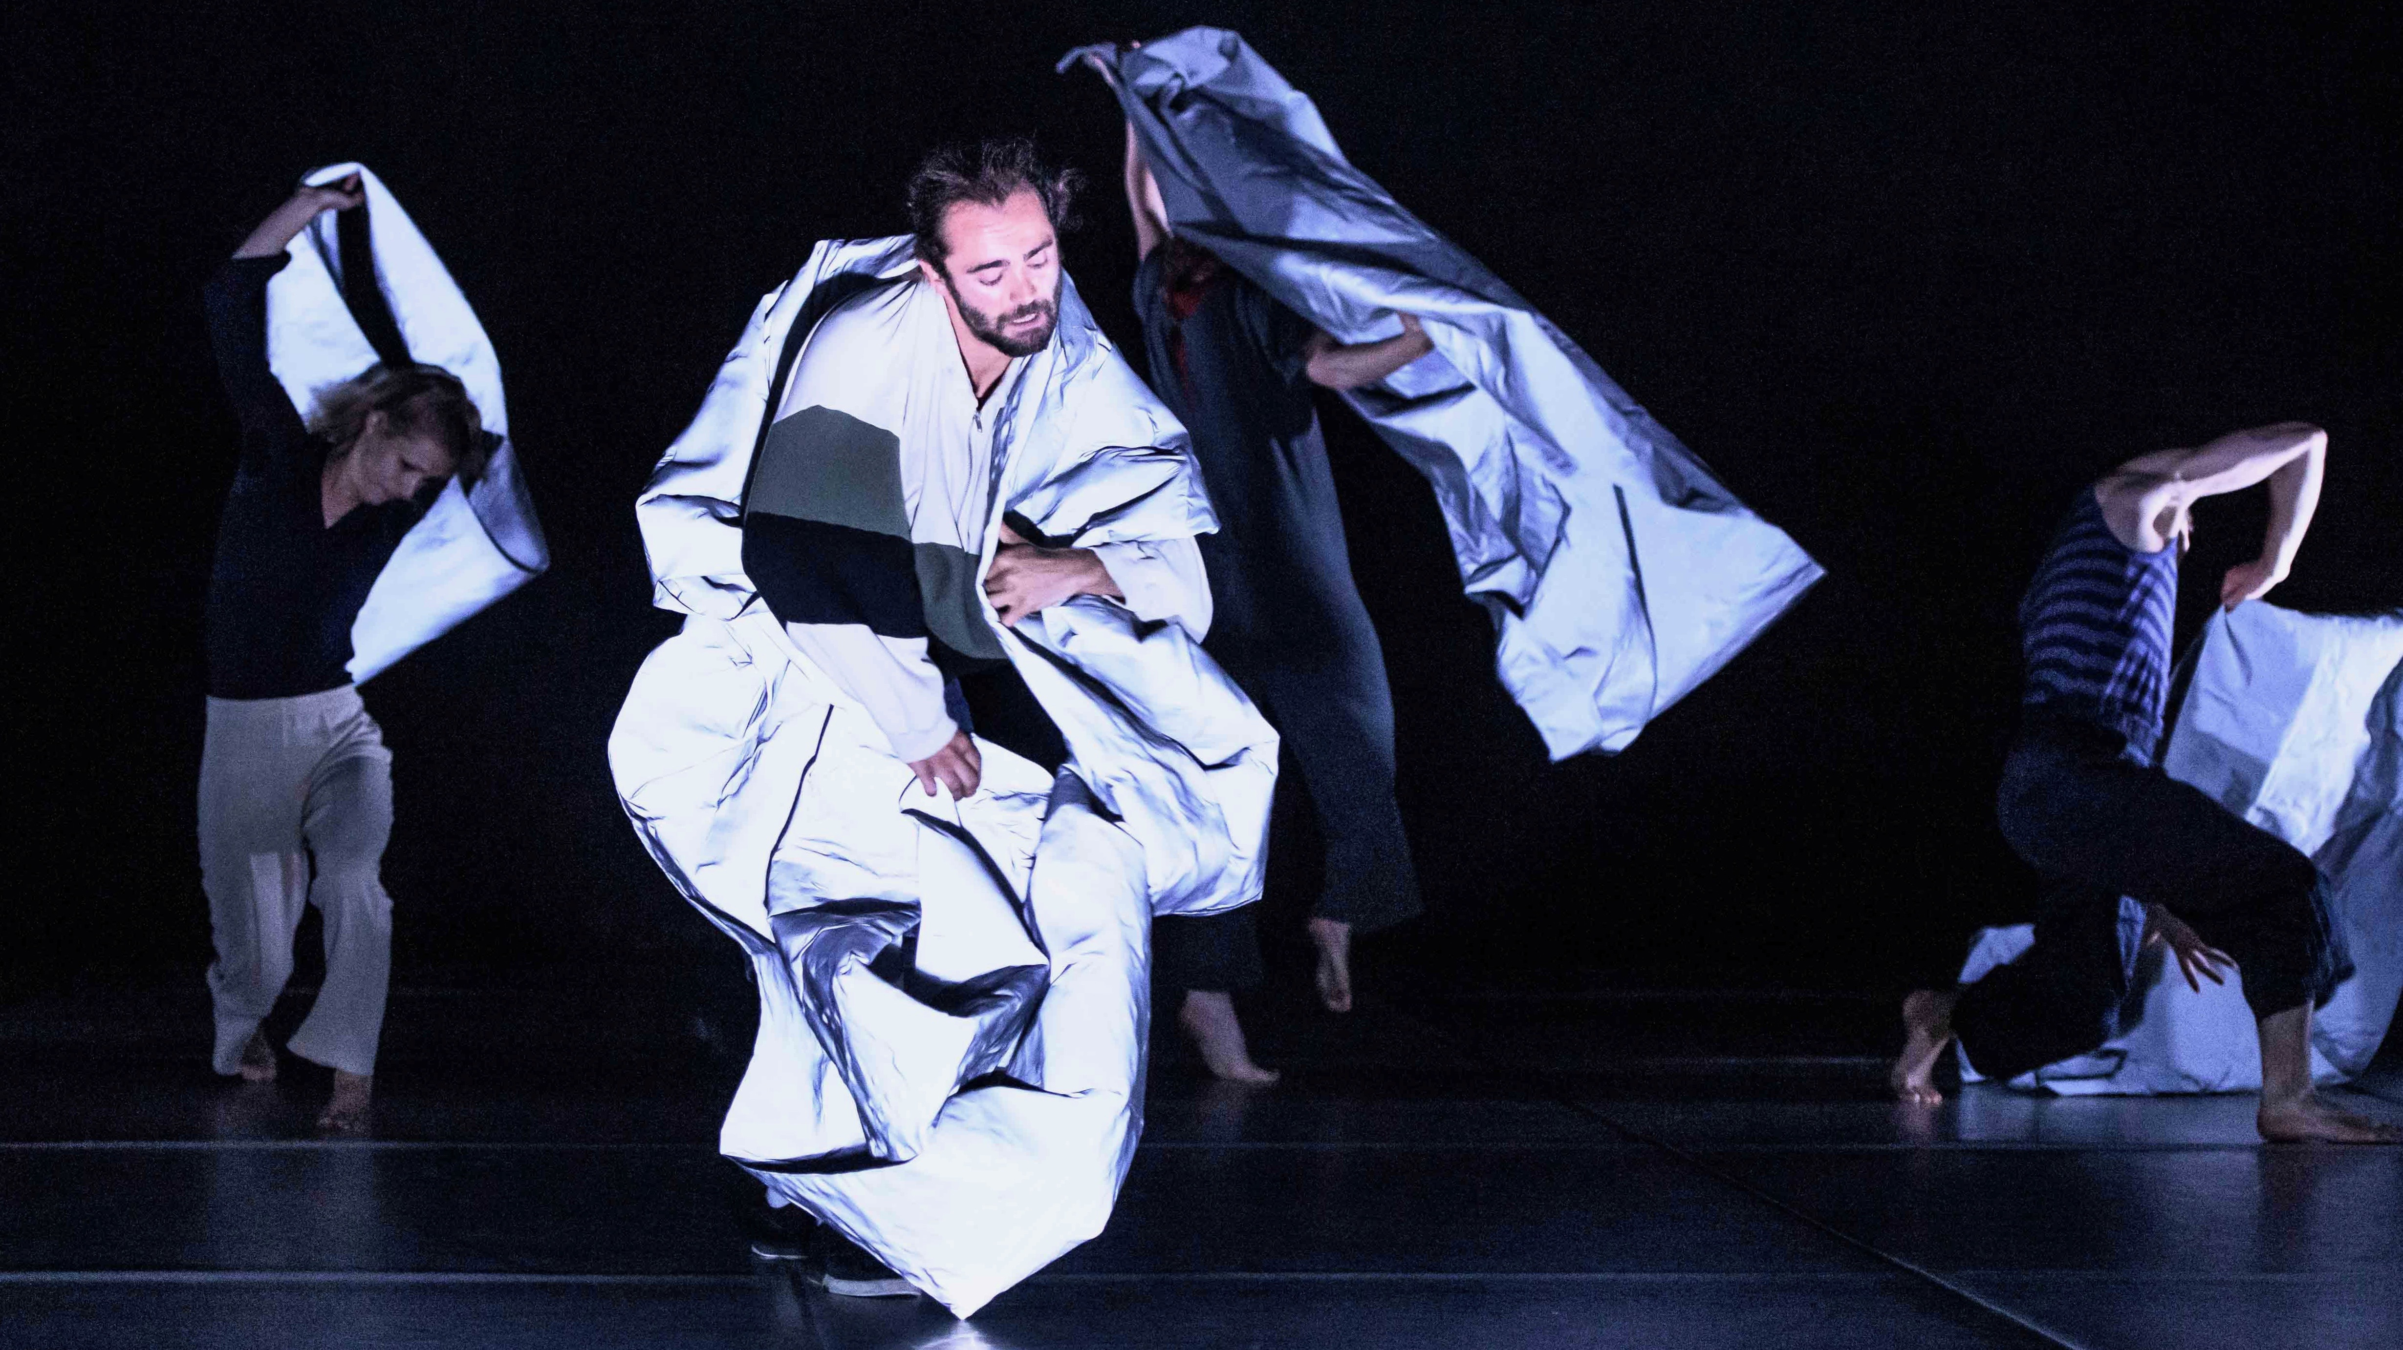
Opening section

The curtain goes up, it is dark. The stage is filled with chaos and we see the dancers manage and negotiate heaps of silver fabric. The dancers appear to be tangled in the material.

We hear crackling, drone-like sounds and the ticking of a clock as if counting down. As the music fades, the energy of the dancers increases. They oppose the music, as if moving to their own beat.

The dancers become heavier as if drawn to the floor. There is a sense of increased effort, weight and collapse.

The lights go up.

There is a suspended moment in silence where the dancers register each other for the first time. We see a gradual progression from individual acts to group acts, from separation to contact, from silence to speaking. They are learning different ways to meet, measure and collaborate.

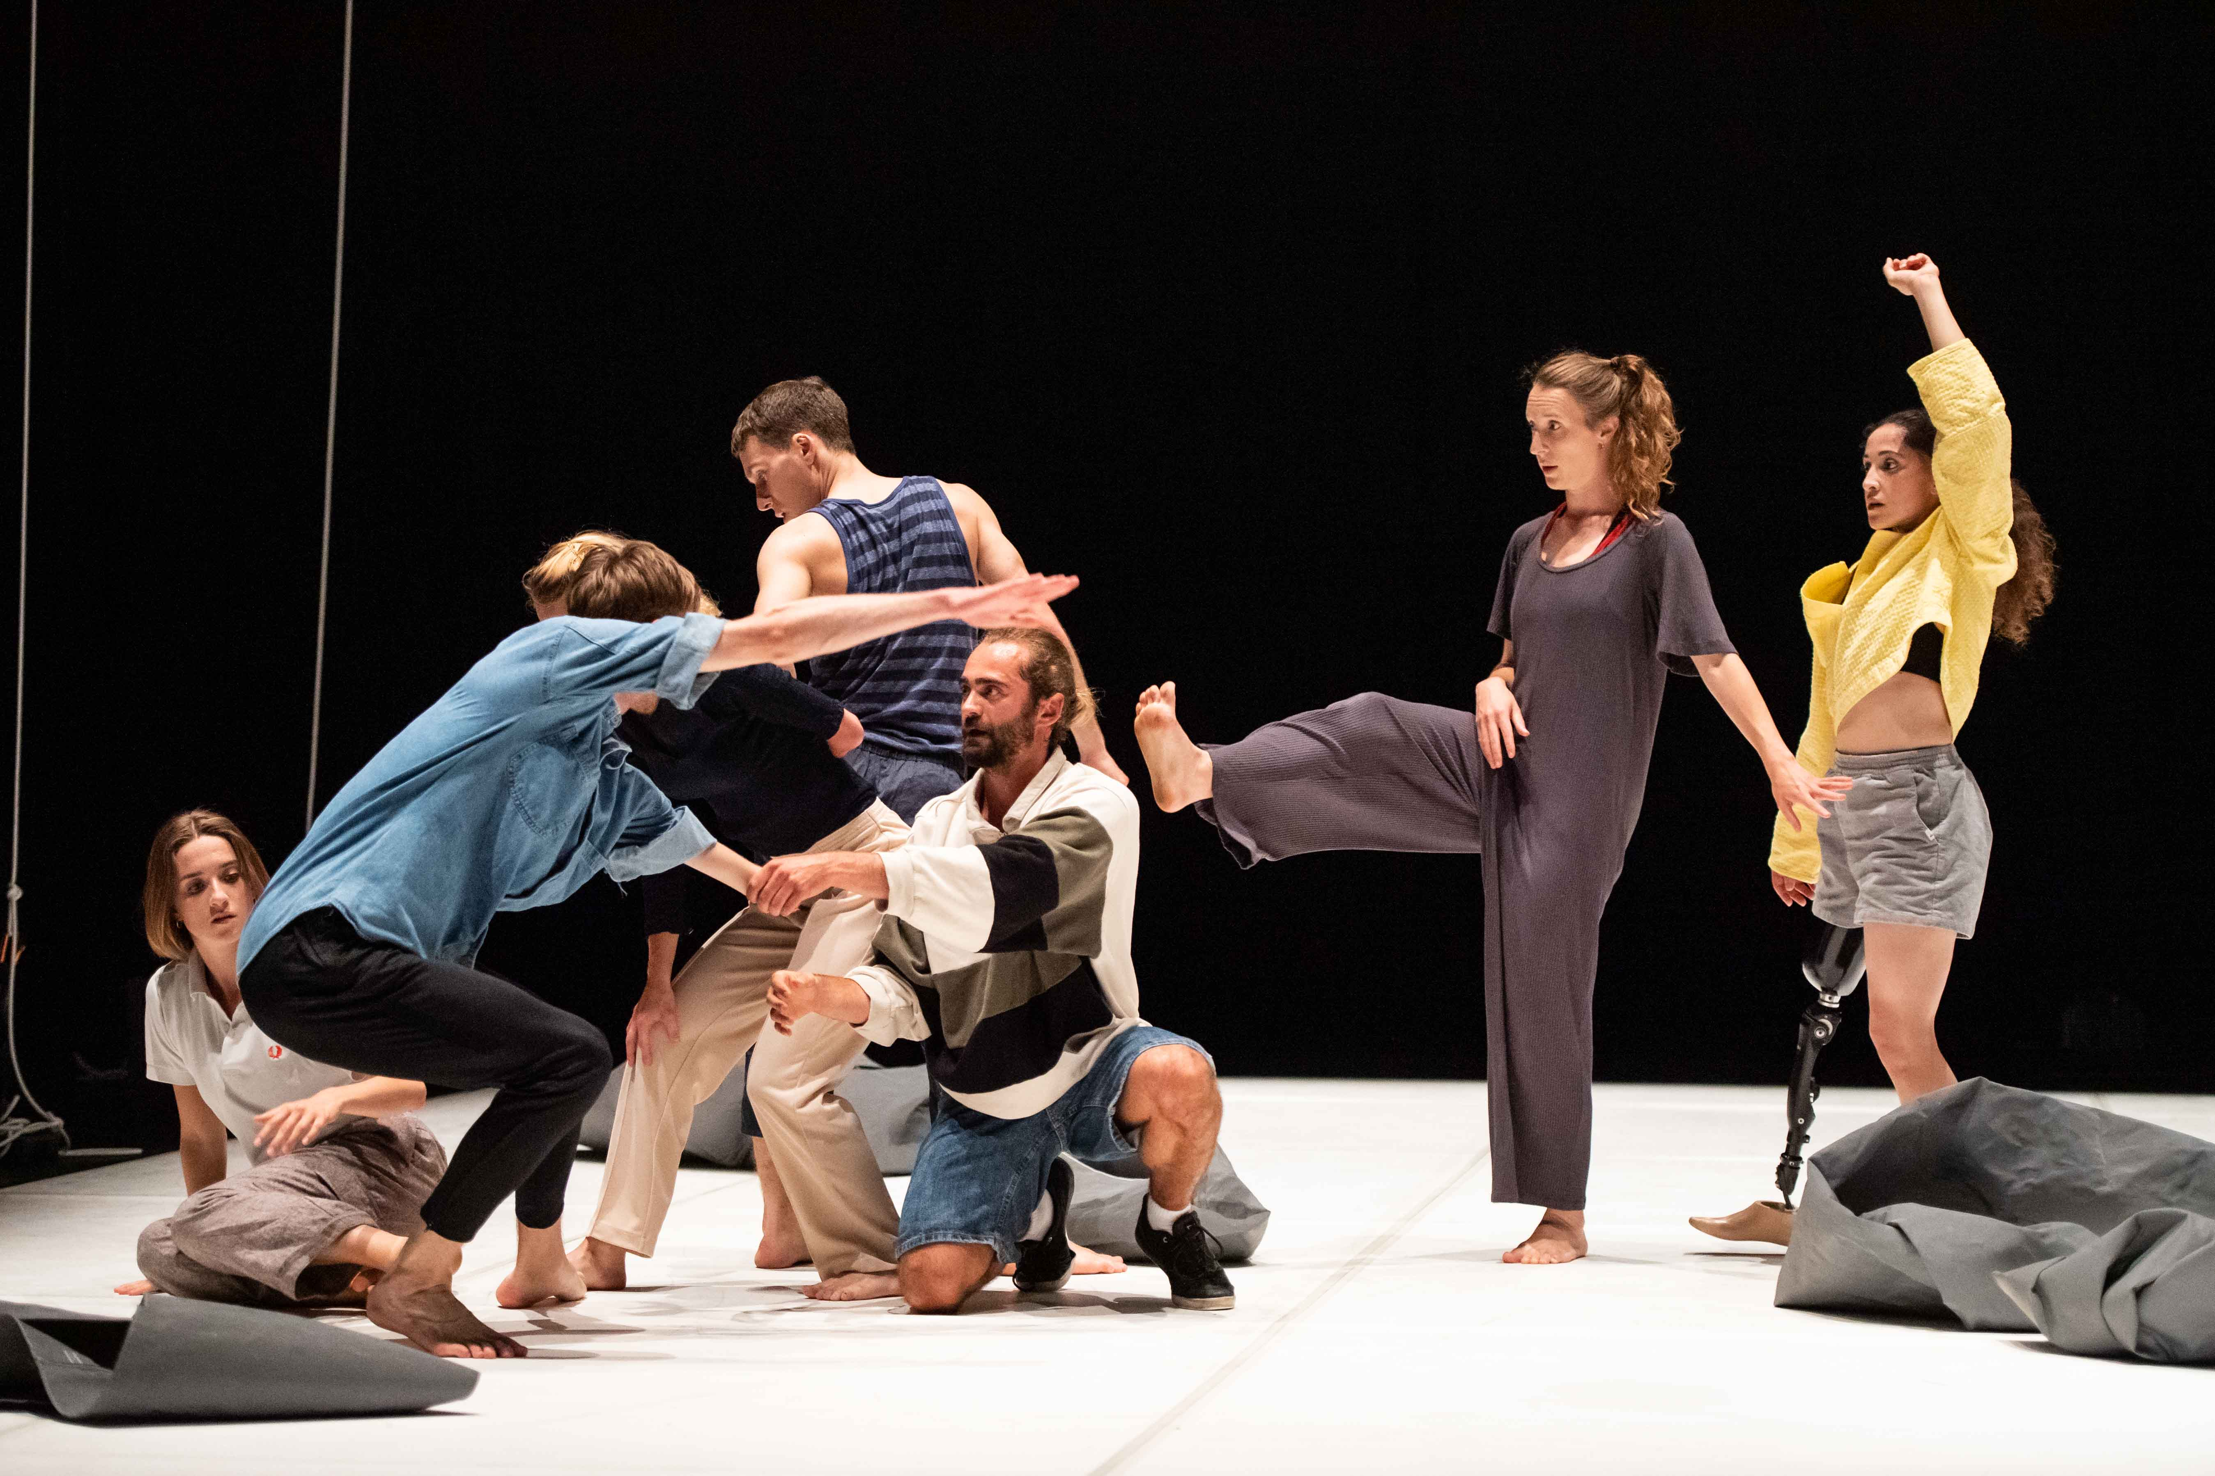
‘Ready? And…’ section

We see the group try do something together but they don’t seem to know what it is they are trying to do and how to do it. It seems to be a negotiation between the individual and the group. Navigating the known and the unknown becomes an organising force.

There is no music, you might hear the sounds of the dancers moving around the stage.

The second time someone shouts ‘Ready? And…’ it cues the music – a loud, repetitive, energetic panting sound. Different dancers choose to call ‘Ready? And…’ as they try to achieve something together.

The group exits and appears to silence the music. Joel is left alone. Joel begins frantically taking his arms up and back in circles. He stops with his arms lifted above his head in an attempt to challenge and find his balance. He exits.

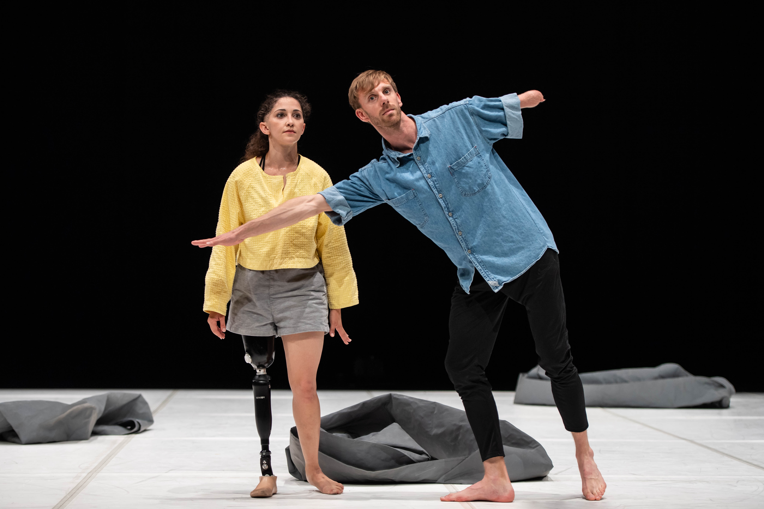
‘Potential Dance’ section

Toke enters and stands alone, he observes the audience for the first time. He begins a practice that Mickaella soon joins and in time, the other dancers join too. The practice involves the performers seeing the audience and allowing the audience to see them. It also researches the beginnings of movement that is never fully established.

The music sounds like fire crackling and whistling.

The couple drift diagonally upstage and collect two more dancers, Nicolas and Olivia. They cross the back of the stage and drop Toke off, the music fades to silence momentarily. Different dancers join or depart but all have the same enquiring vision. It seems that how they see informs their dancing.

Toke is left alone in silence again. He starts to test different movements that are bigger now. They suggest modern dance forms but his active gaze suggests he is wondering about things whilst moving. The others join him, collecting the fabric and using it to frame Toke, which evokes images from classical paintings. This can seem quite funny.

A dancer drops the fabric and shouts ‘Now’. The group responds by running in but is interrupted by a blackout (the lights cut to darkness).

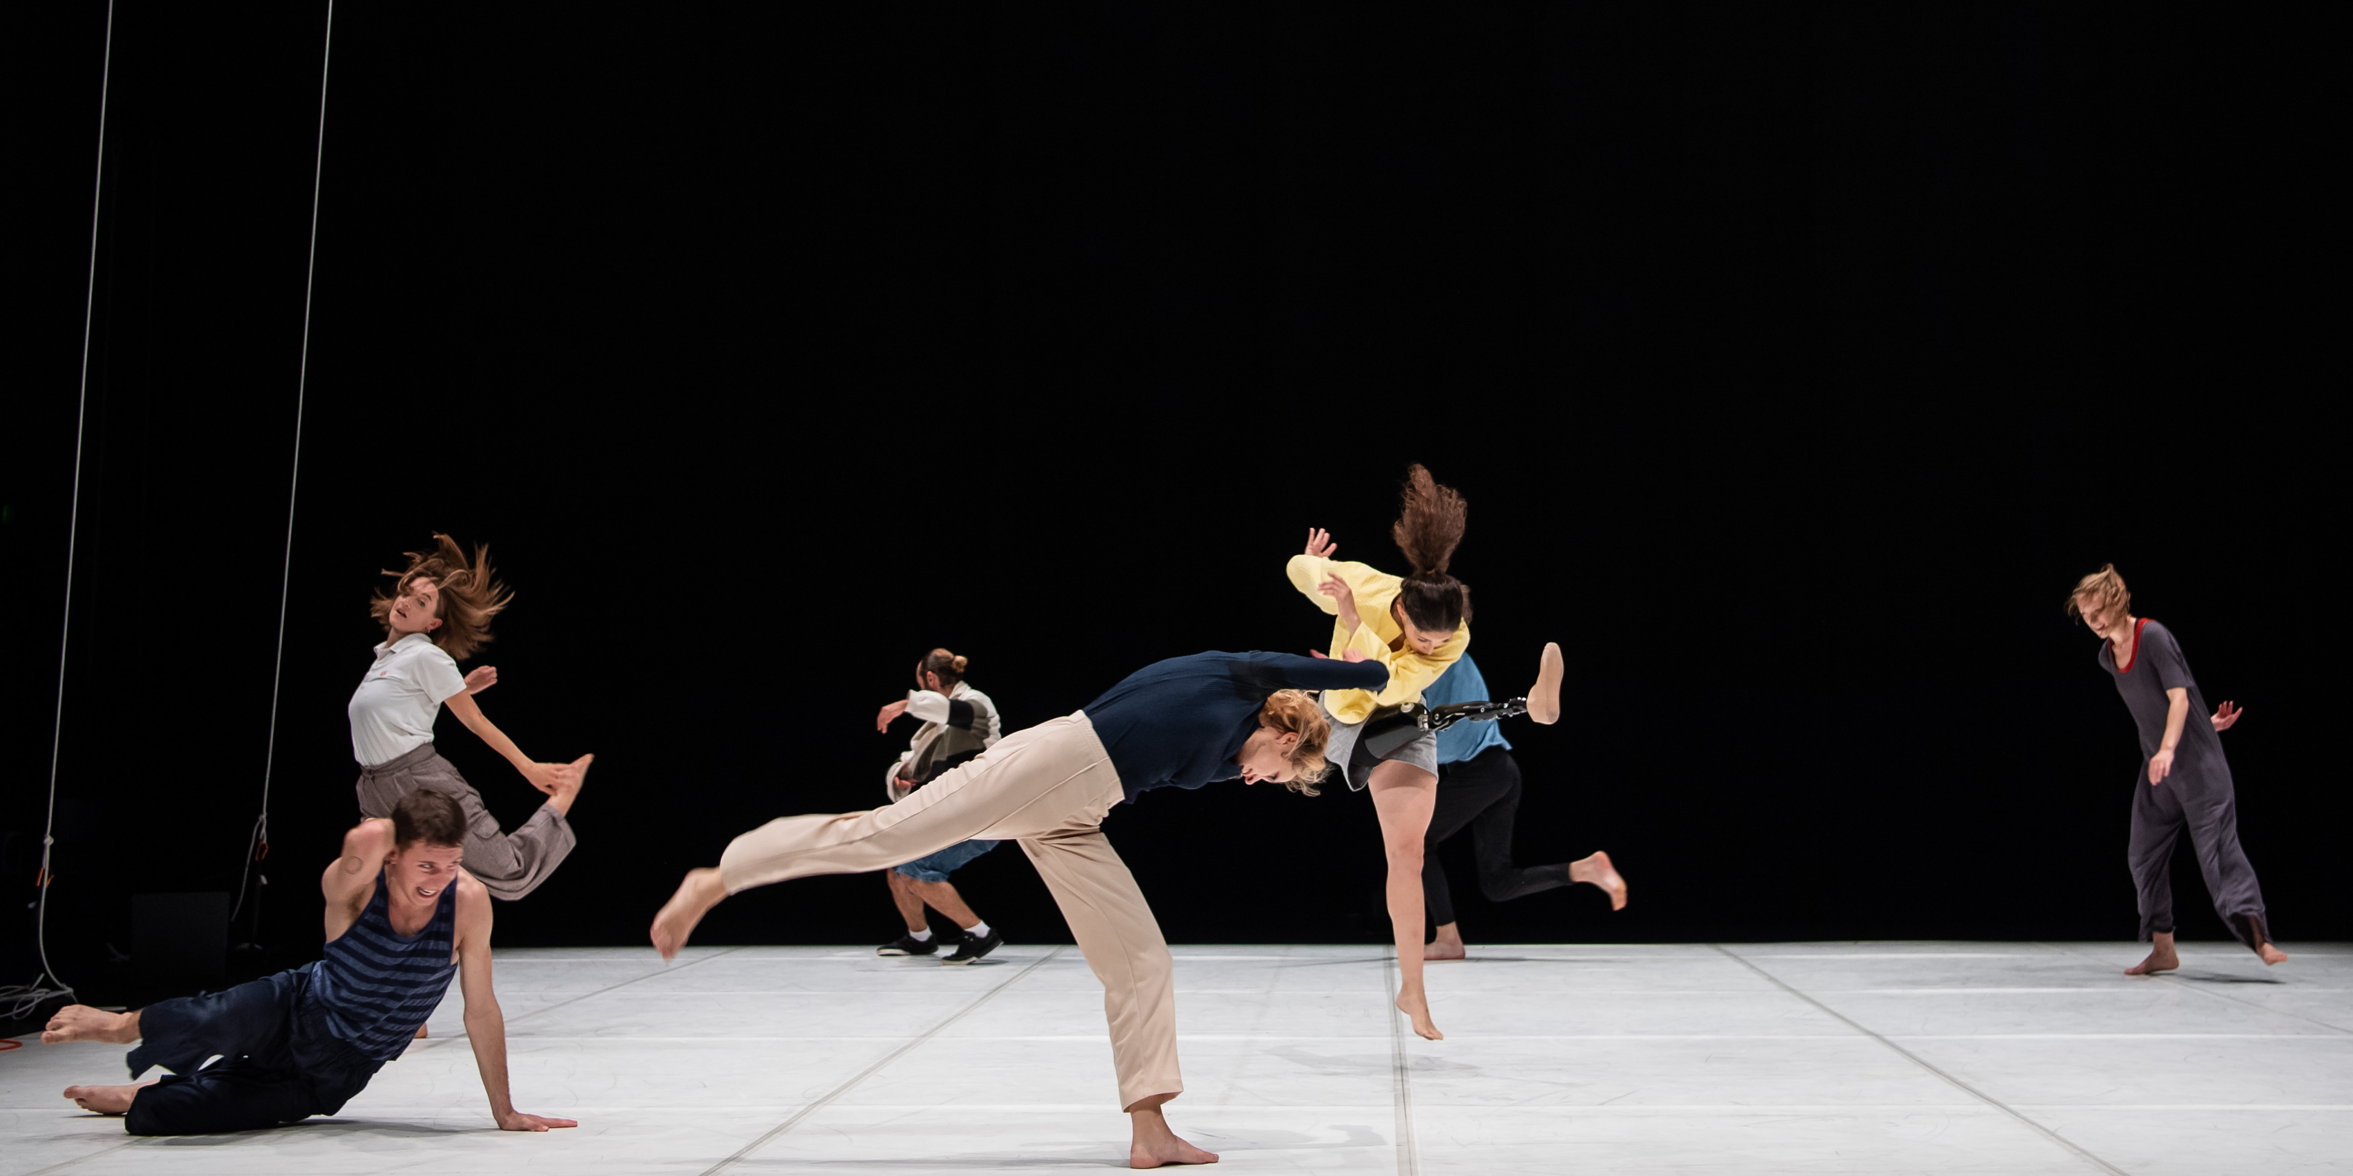
‘Now + throw’ section

The lights go up and we encounter the dancers as they attempting to be still like statues. Each time they start dancing, the lights cut out again so we only see them launch into action and then struggle to balance.

Sometimes we can hear them moving in the dark but we can’t see them. This switch between light and dark continues and a sense of play emerges between the dancers.

Then, the game changes. The lights remain bright and we can see them. The group choses when to stop and when to move. Their actions resemble directional throwing actions, sometimes throwing body parts in to the air and at other times it’s as if they throw objects.

The final call for ‘Now’ cues a lighting change and discordant guitar music plays. The repeated action of throwing offers a new and explosive physical energy. The group seems to agree more and find some cohesion.

Someone shouts ‘Trees’.

They stop and form a line. They look at each other and silently agree to find balancing positions, some of the dancers are upside down, Megan repeatedly attempts a handstand that she can’t quite sustain.

Music breaks down in a discordant way. There is silence.

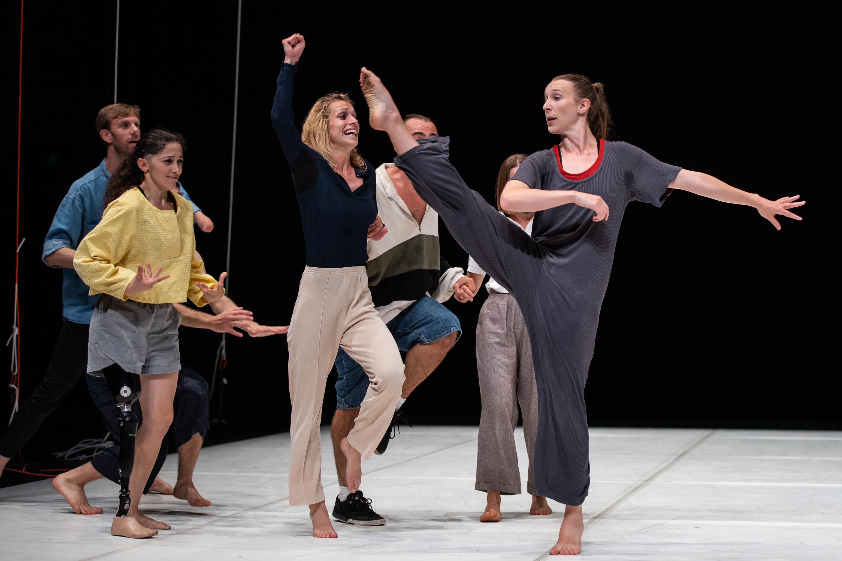
Megan and group section

Megan makes her way to the corner to initiate a new task. Just as a gymnast prepares to do a daring and virtuosic stunt, Megan takes the necessary preparations to do a set routine but never fulfils her goal.

Megan resets and tries again numerous times. The other dancers do whatever they can to support her in her quest to complete her routine, even though they don’t know what it is she is trying to do. Sometimes they echo her movement and embody her energy through movement and sound, sometimes they misjudge what it is she trying to do. It can, at moments, seem absurd, intriguing and amusing in equal measure.

As Megan approaches her final goal, the lights cut to black we are asked to imagine her defining moment. We hear the celebratory sounds of the dancers as they celebrate her achievement (which could have been the attempt in itself all along).

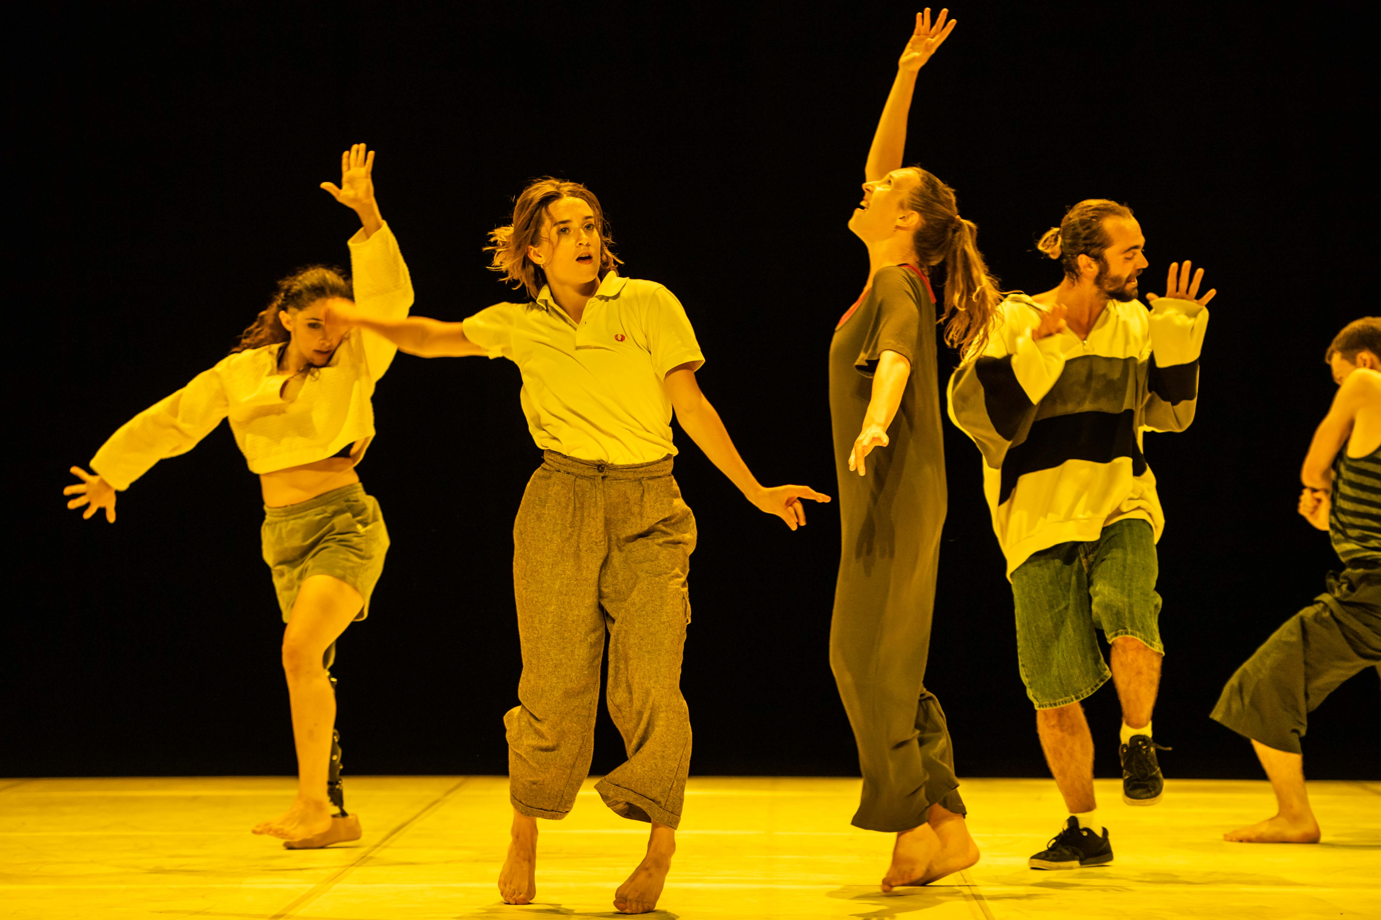
Hot mess section

The lights come up, and the stage is completely saturated in yellow light.

Soon after that, 2 flashing police lights are lowered into the stage, they don't stay on for very long (around 30 seconds) if you want to close your eyes, that’s fine, there will be lots of dancing to listen to.

We catch the dancers immersed in their own worlds, their independent activities run simultaneously with the rest of the group.

The music is an upbeat, hip-hop soundtrack. Some dancers shout or sing as they revisit actions from earlier in the piece. The dancers also play with the silver fabric, including hanging it from ropes. They make the fabric plummet and swing in the air. We see the whole theatre animated with chaotic action like the beginning, but this time we see they are creating that anarchy themselves.

Joel introduces his arm circles from earlier in the work and, as the other dancers notice him, they join his action. They each find their own version and for the first time we see the whole group, united and in-sync. Their collectivity energises the whole space and they turn towards the audience.

Another moment of pause comes as they complete this action all together. It feels like the ending has just happened, but we are left, in suspension wondering what will emerge next.

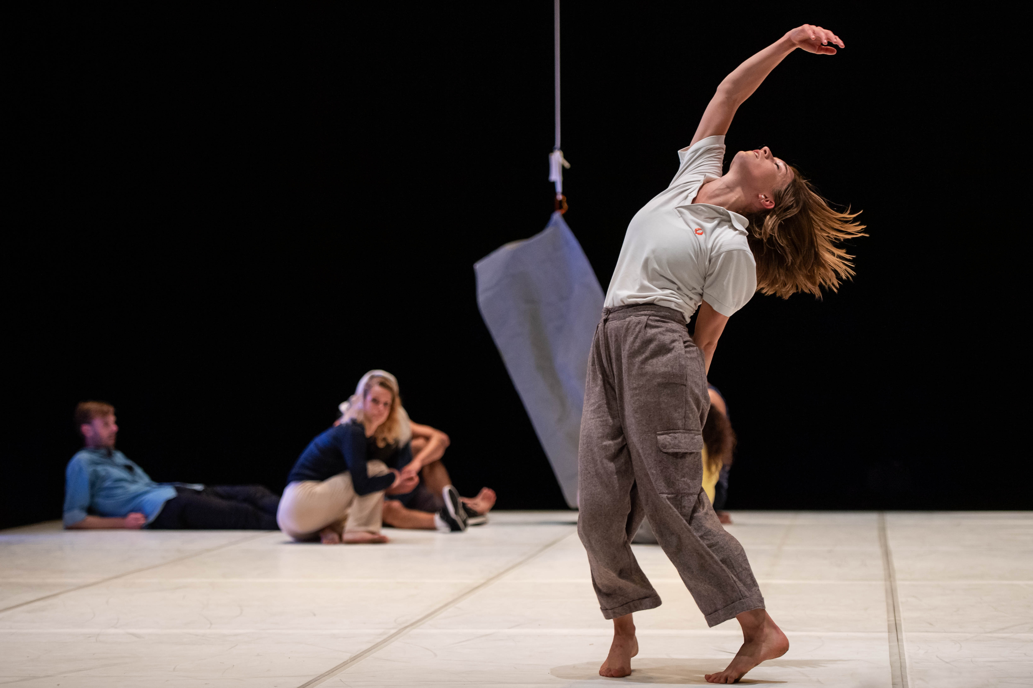
Olivia’s solo

Just as we think the work is finishing, the dancers remain on stage, they seem to remember movements, find places to settle or wander into the distance.

As some dancers quietly whistle, Olivia launches into something new.
She sometimes appears to be making herself move and sometimes letting movement happen to her. Some actions are defined, whilst others soften and disappear. She is in an ‘in-between’ state’ not fixed, but defiant. Her attention is alert and we imagine she might continue forever.

Whilst Olivia continues, the curtain gently falls.

DURING THE SHOW

During the show, you might find something funny, you can laugh if you like. You might also see or hear something that makes you feel sad. You can feel sad if you like, that’s okay.

You might hear other people in the audience cheer and clap. You can join them if you like.

The Bristol Old Vic team will be on hand to help.

Thank you for coming to see Candoco Dance Company!

TELL US WHAT YOU THOUGHT:

If you have any feedback please contact-

Bristol Old Vic
0117 987 7877
Candoco Dance Company
info@candoco.co.uk
020 7704 684

