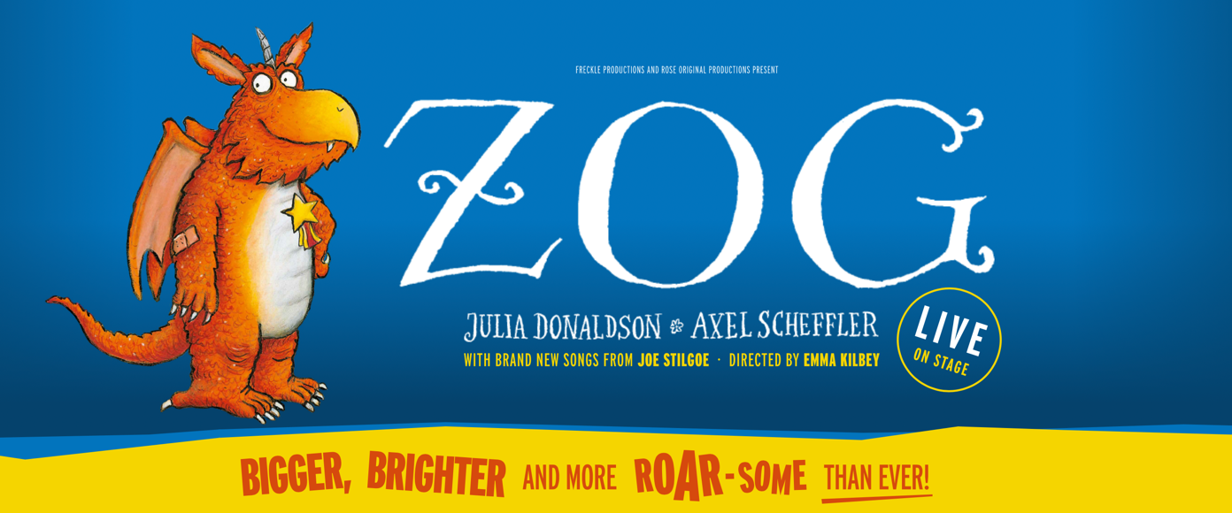

ZOG
Visual Story

Presented by Freckle Productions
Based on the book by Julia Donaldson & Axel Scheffler

This visual story is designed for visitors to the Relaxed Performance of Zog. Relaxed performances are for people who will benefit from a more relaxed performance environment including people with an Autistic Spectrum Condition, sensory or communication disorders, or a learning disability. This document contains information about the play and lots of images to help prepare you for your visit.

The actors and the characters they play.
The play is performed by five actors and they all play different characters. They all sing and sometimes play different instruments too. You will also see them working with lots of puppets.

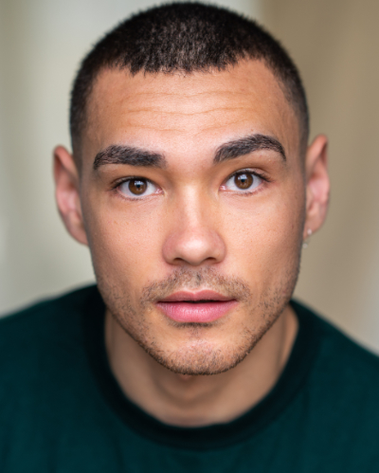
← Danny Hendrix
Danny plays Zog – the biggest dragon of them all!

You will see him flying around and trying his best to win a golden star. You will also see him play some small percussion instruments.


Lois Glenister →

Lois plays Pearl – she’s Zog’s best friend!

She sings and dances a lot. She also puppeteers the frog (his name is Steve).

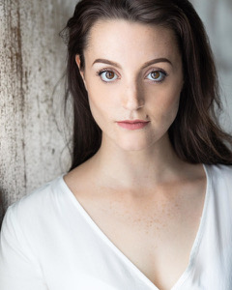
← Louise Grayford

Louise plays Madam Dragon – she runs the school. She teaches the dragons how to win a golden star.

Louise also plays Pearls mean governess!

Benedict Hastings →
Ben plays Sir Gadabout – he isn’t the best knight and is often rather silly!

Ben also plays Edwin (the blue dragon) who is one of Zog’s friends.

You will see him playing some small percussion instruments and the trumpet.

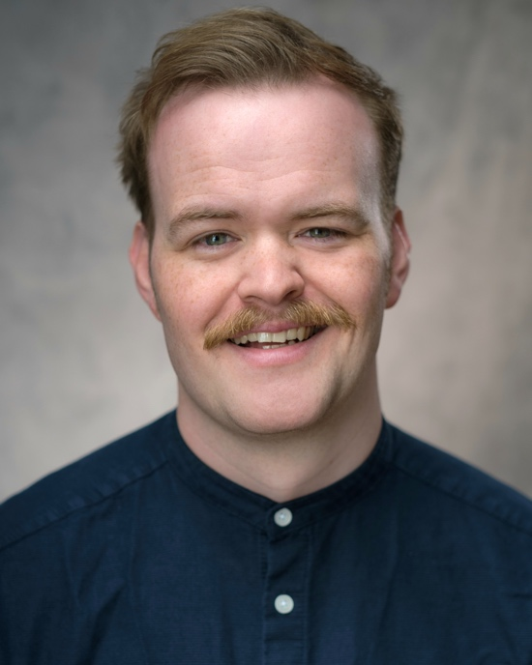

← Eliza Waters

Eliza plays Ronnie (the pink dragon) – she is very cheeky. She does lots of singing and also plays some small percussion instruments.

She also covers the roles of Madam Dragon and Princess Pearl if anyone is feeling poorly.

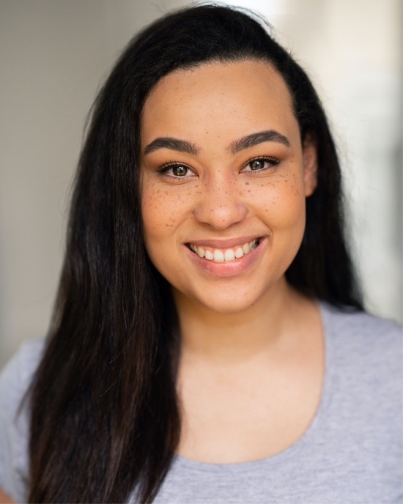

Rhys Wild →

You might also see our wonderful ASM/Understudy Rhys.

He helps with lots of things backstage and he also covers the roles of Zog, Gadabout and Ronnie if anyone is feeling poorly.



What happens in the play.

The performance is around 55 minutes long. You can leave the show at any time and come back in whenever you like.

At the start of the show, lots of woodland creatures come out to say hello. They are all puppets, and they are very friendly. You will see an owl, a squirrel, two rabbits, two crows and one frog (this is Steve).

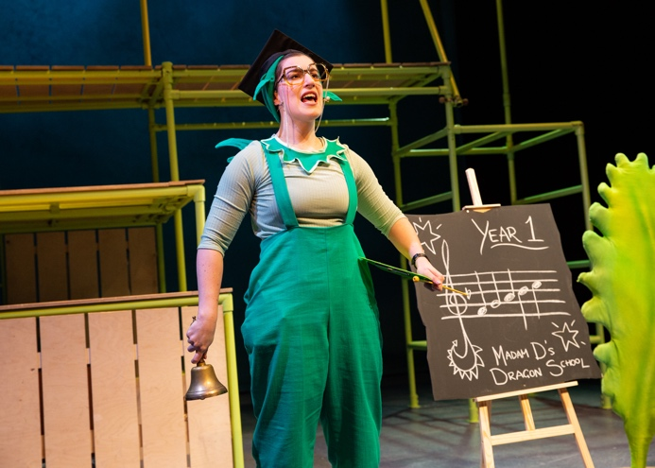
Then Madam Dragon comes on to start off the school day. She rings a bell which might be a bit loud, but it doesn’t last long.

You can listen out for the bell throughout the show as you will hear it a few times – it means Madam Dragon is coming!

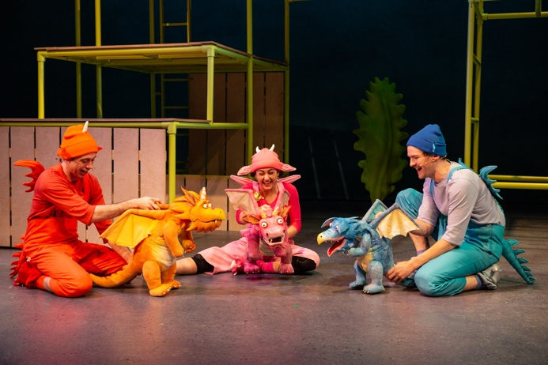
Next Ronnie and Edwin will arrive for school. You may see Zog coming through the auditorium as he is often late for school.

They play their school song on glockenspiels – this is a small percussion instrument that makes a tinkly sound.


Zog then sings a song about how much he wants to win a golden star. He does lots of climbing on the frame!

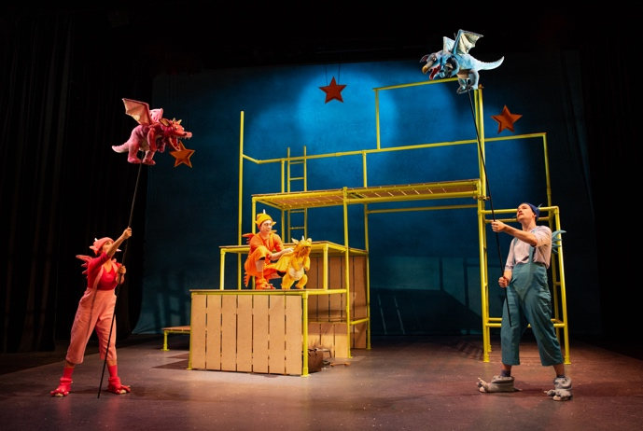
The first thing Madam Dragon teaches the dragons is how to fly.

Zog and his friends sing about trying to learn a new skill. Edwin and Ronnie learn very quickly but Zog finds it a bit tricky.

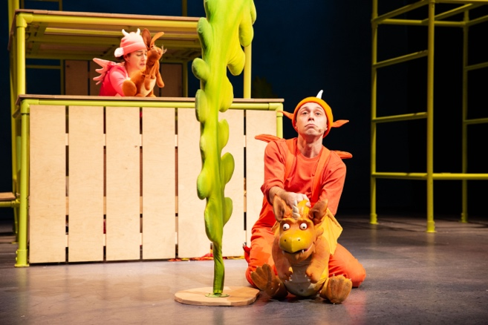
After lots of practising and a song, Zog manages to fly. He gets so excited that he crashes into a tree!

Luckily, Pearl sees him fall and wants to help so she asks the woodland creatures to get her bag.

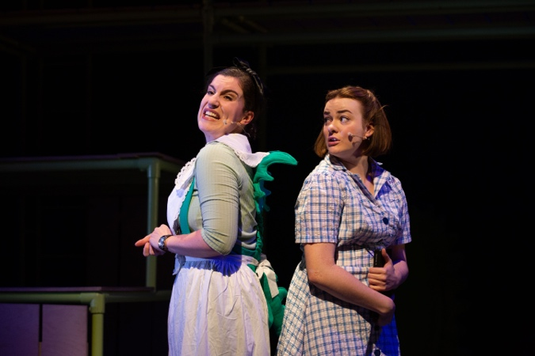
Unfortunately, Pearl’s Governess appears and reminds Pearl of all the things she should be doing as a Princess.

During this song, Pearl manages to sneak away so that she can get back to helping Zog.

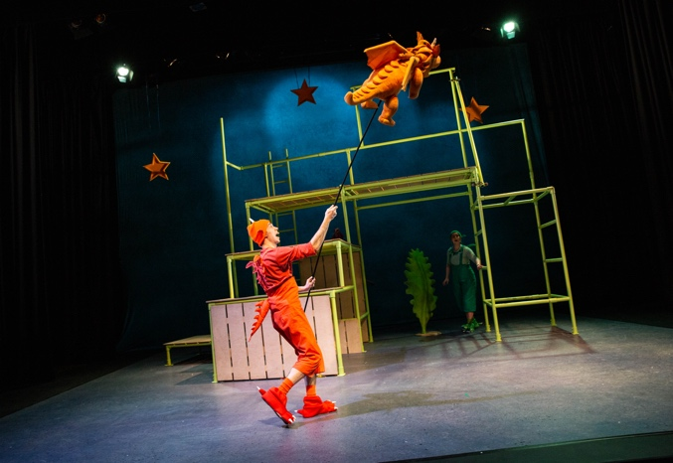
Pearl gives Zog a nice sticky plaster for his head and he feels much better.

He flies off and zig zags through the blue. When he flies, you may hear a rumbling sound, like a plane engine – but this doesn’t last long.

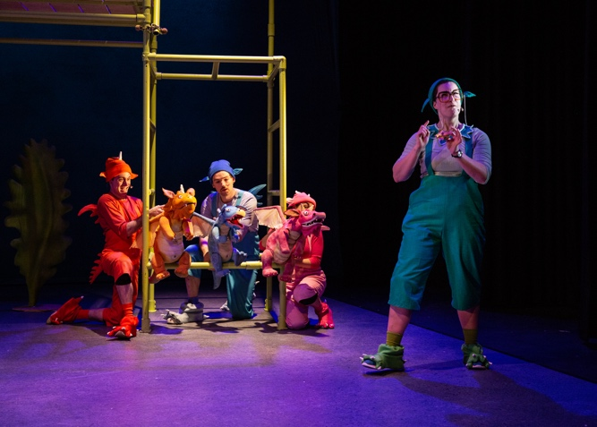
Madam Dragon gathers the dragons and gives the golden star to Ronnie!

Zog is a bit disappointed that he didn’t win the golden star this time, but he quickly gets another chance as in Year 2 the dragons learn to roar…

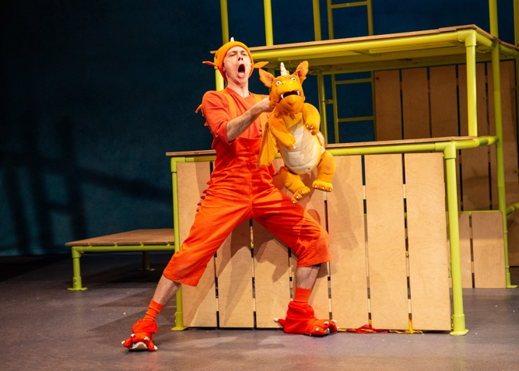
Madam Dragon does a very load roar at this point. She will do it twice and you can cover your ears if it is too loud.

Zog practices his roaring for so long that he gets a sore throat! Pearl gives him a peppermint to suck and it soothes his throat.

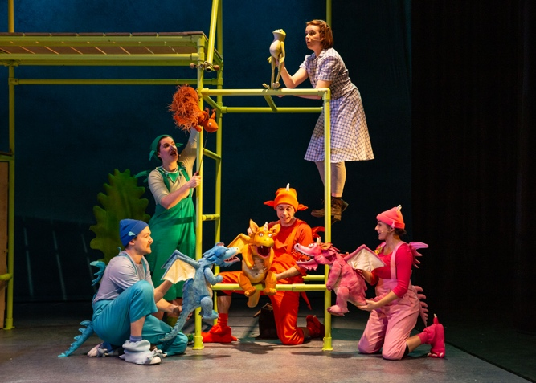
Zog and all of his friends sing a song about what their breath smells like… some of them have eaten some rather disgusting things!

Madam Dragon comes back and this time it’s Edwin that wins the golden star. Zog is disappointed again and runs off…

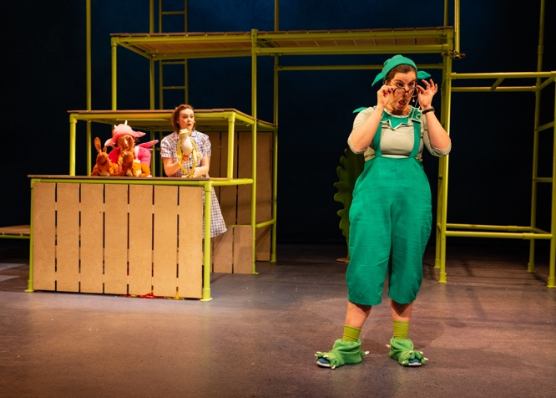
Madam Dragon speaks to the audience about how it can be very difficult to learn new things. She does a few tongue twisters and encourages everyone to join in.

There might be lots of people talking at this point as it is an exciting game.

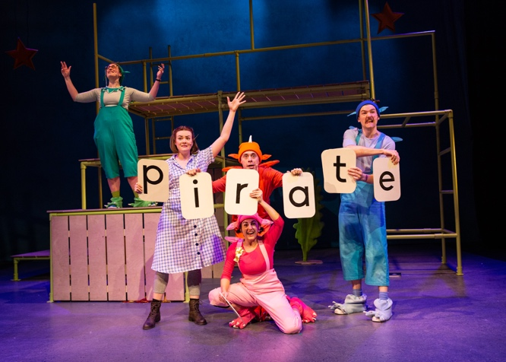
The dragons come back and join Madam Dragon singing a song about how important it is to practise when you are learning new skills.

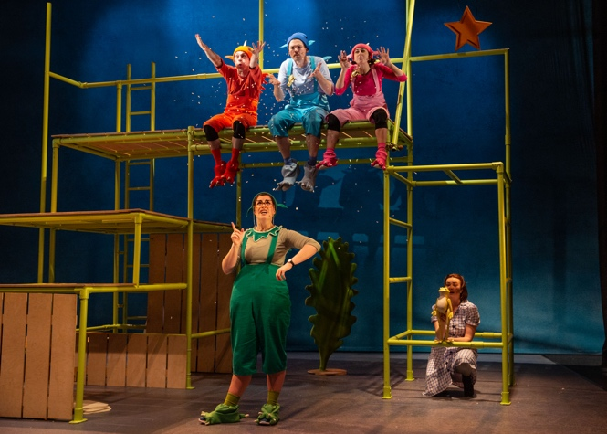
In Year 3, the dragons learn to breathe fire. They can’t do it at first and end up blowing out snow.

Madam Dragon shows them all how it should look and breathes out lots of fire. There is a fire sound which might be a bit loud, but it doesn’t last long.

All of the dragons practise blowing fire, Ronnie and Edwin come into the audience to practice (but don’t worry its only pretend fire).

Zog accidentally sets his wing-tip alight. Pearl comes to his rescue again and gives him a nice stretchy bandage for his wing.
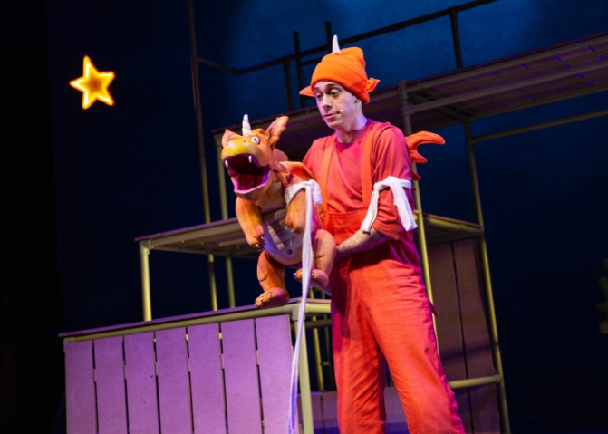

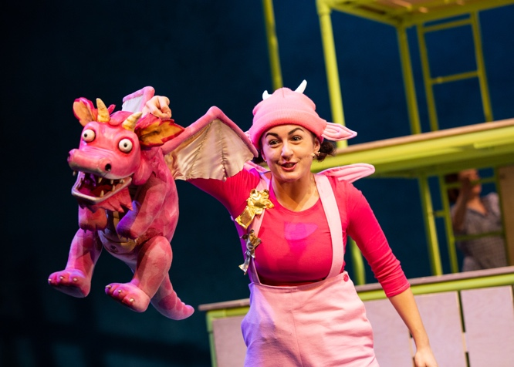
Ronnie wins another golden star which makes Zog very sad. He sings a short song about how he feels he will never win a golden star.

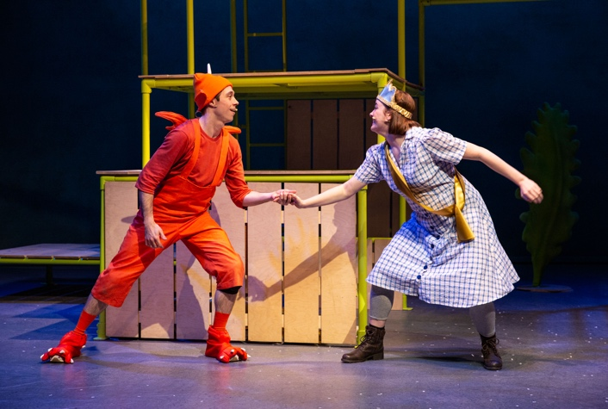
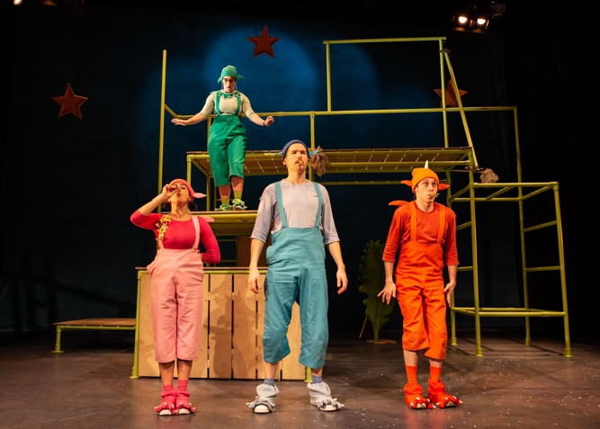
Zog is the only dragon that can’t find a princess. He feels very down about it, but then Pearl reveals that she is a princess and says Zog can capture her.

They sing a song about how they can both do anything with their best friend by their side.

In Year 4, the dragons learn how to capture a princess. Madam Dragon asks the audience where she should hide the princesses. There might be lots of talking from the audience as they give suggestions.

The dragons use their kazoos to play a marching song which repeats whilst they are looking for princesses.

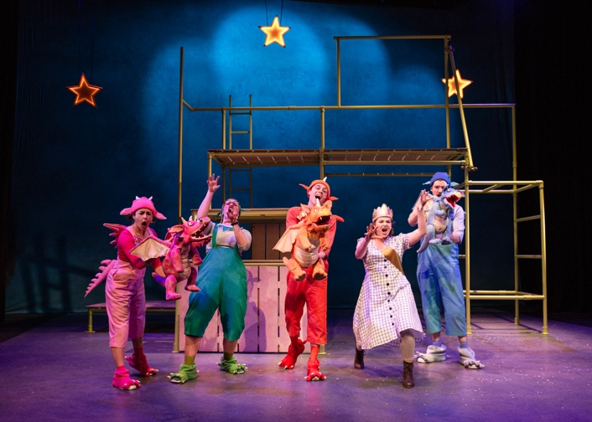
Zog finally wins a golden star and he is so happy about it.

Everyone does three cheers to celebrate Zog’s success. They all do three roars, but they are very short and not very loud.

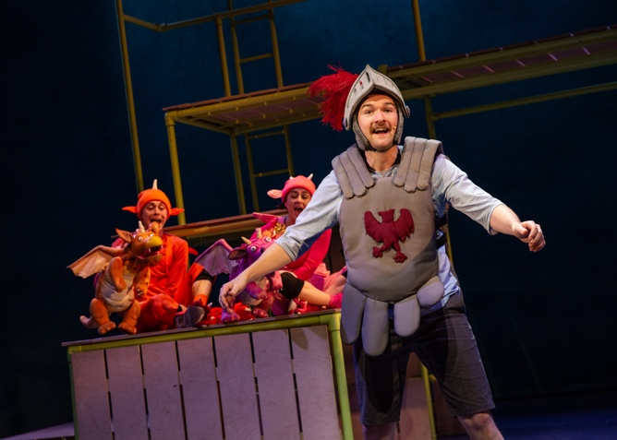
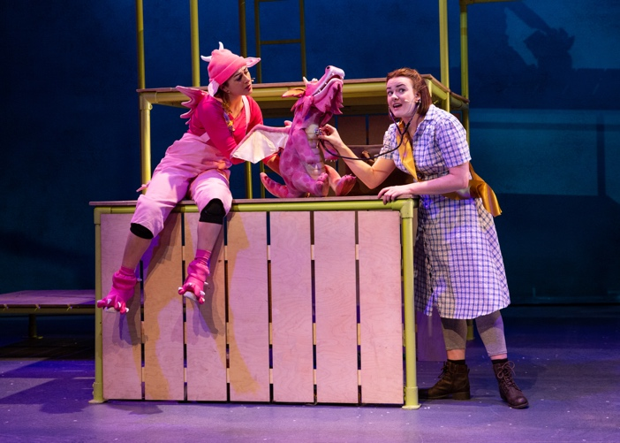
Pearl looks after all the dragons and nurses them when they are unwell.

Madam Dragon and Pearl sing a song about being brave and knowing you can do anything you set your mind to.

Zog plays the glockenspiel during the song.

In Year 5, the dragons learn to fight. Sir Gadabout the Great arrives through the audience on his invisible horse.

The galloping noise is made by Pearl who is tapping two coconut shells together. There is also a horse sound effect which is played.

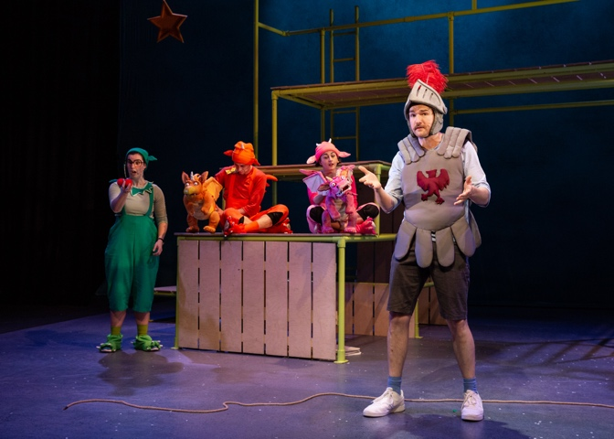
Gadabout sings a song about all of his different hobbies. During the song he plays the trumpet.

After the song, he tells everyone that he has come to rescue Princess Pearl. Zog doesn’t want Gadabout to take Pearl away and the two start to fight.

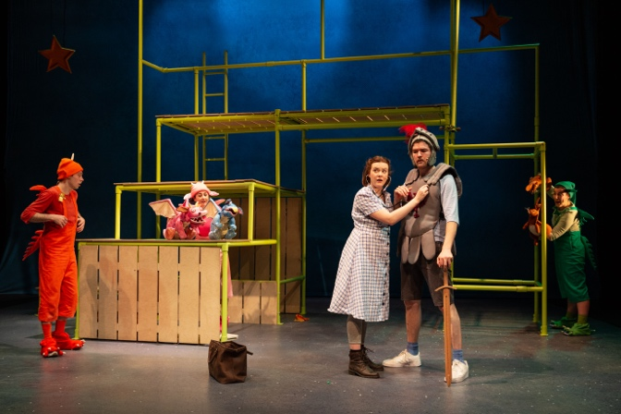
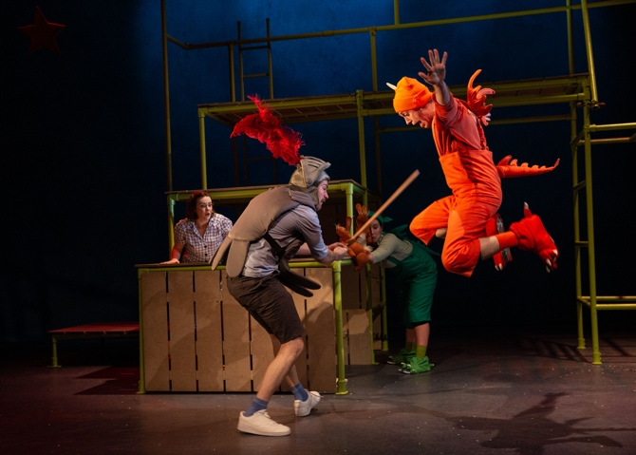
Pearl steps in to break the pair up. She tells everyone that she doesn’t want to be rescued as she wants to be a doctor and look after people.

Gadabout says that he would also like to be a doctor and wants to join Pearl as her assistant.

There is a continuous drum roll as Zog and Gadabout fight, and a couple of loud bangs as Gadabout drops his sword.
You may also hear Zog when he breathes fire and roars.

It is a tense moment, but no one gets hurt during the fight.

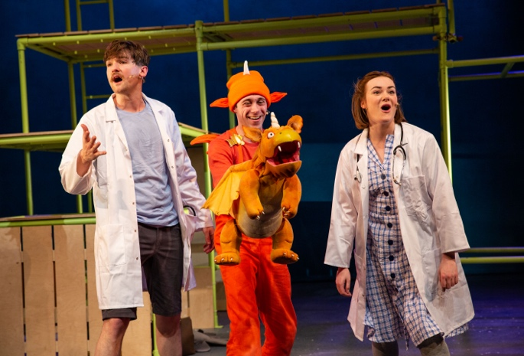
Zog wants to join the doctors and offers to be their ambulance.

Everyone agrees that this is a great idea and there is a big cheer!

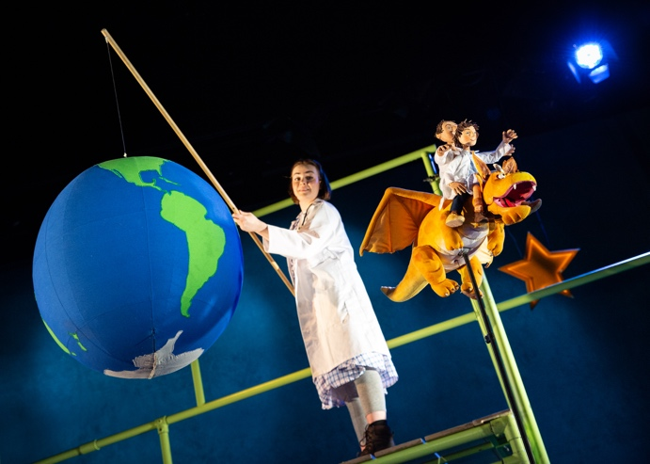
Then, everyone sings a song about being who you want to be. There is lots of dancing and there might be some clapping in the audience at this point.

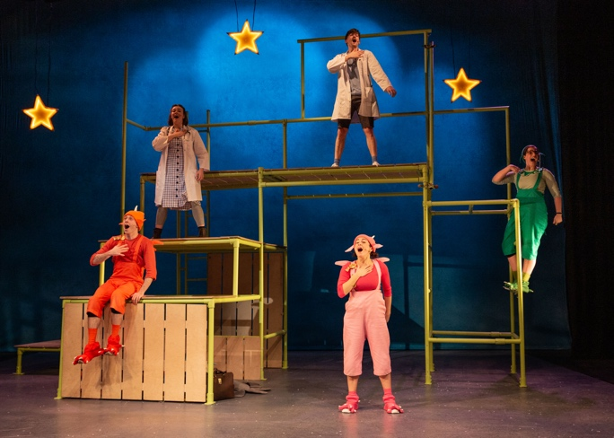

After the song, Zog flies on with Pearl and Gadabout on his back. They fly around the world and then the stage goes dark.

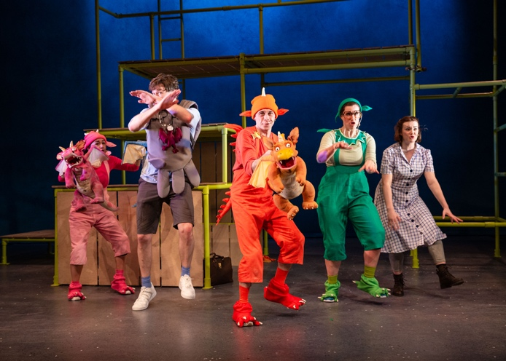

The cast all sing a fun song which has some dance moves in. You can join in if you want to, but you don’t have to.

At the end of the song, the actors will take comes forward to take a bow. There will probably be some clapping from the audience at this point.

Photos: Mike Senior PR.

